Obodovka / Orit Barcay Bar-Shira, Israel, 2012
barcaybar@gmail.com

Obodovka, in Podolia gubiernia, had 1676 jews among 7754 residentes. Today (2012) one can count on one hand the number of jews living there. The jewish neighborhood was and still separated from the Christian part of this village.
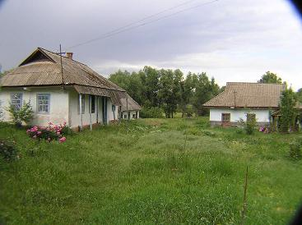
In May 1912, we made a journey to Obodovka.
My father - Shmuel Barcay (Berkovitz) was immigrated
to Israel by himself, when he was 12 years old, leaving
behind him parents and 5 brothers and sisters, older than him.
He was sent to study in the first Zionist school that was established just few years before: Gimnasia ‘Herzelia’.
My father was 56 years old when me and my twin sister were born, after 2 sons- Razi (who is older than us in 7 years, and Ztachi (Issic), who was older than us in 9 years and was killed in the Israeli Army when he was 19 (in 1/3/1966).
My father’s never talked about his childhood there in Obodovka, and here in Israel- Probably didn’t want to open his wounds and memmories – his father, Issic Berkovitz, and brother, Zeev Berkovitz, were murdered in 1919 pogrom. After that, his mother Tzipora (Fiega) Berkovitz, and 2 sisters, Yehudit
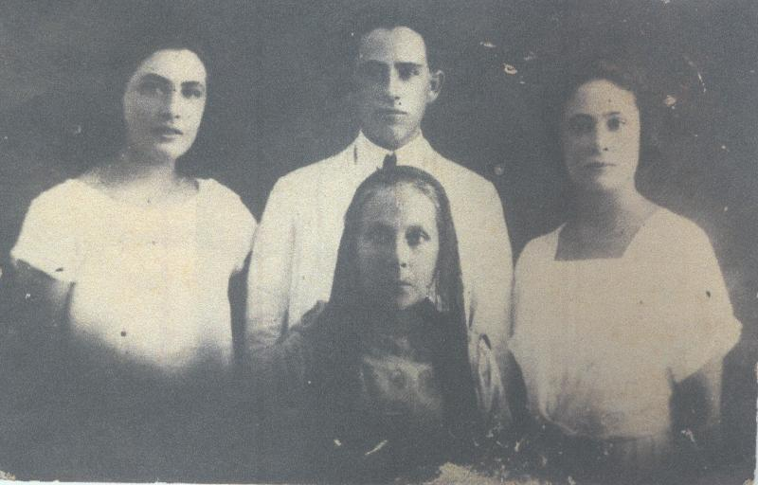
and Bela (who changed their family name to Barcait,
made Allia to Israel (None of them weren’t getting
married. Yehudit became one of the main actresses
of ‘Haoel’ Theatre in Israel).

His second brother, Nahum Berkovitz, who was older than Shmuel in few years, was murdered with his family years later, in 1942 by the Nazis (see picture next page), leaving my father with one sister, Miriam Machtei, who lived in Moscow and died there in the 60th of the 20th century.

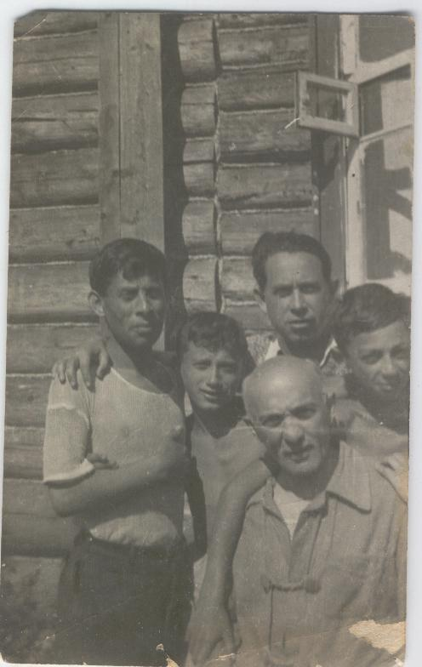

My father, Shmuel (above to the right), while visiting Nahum and children in Obodovka, in 1936 (the older man- probebly- wife’s father)

For years I’m researching my father’s past, including my Tesis in Haifa University on his studies here in Israel, in this unique school, Gimnasia ‘Herzelia’.
This year - 1912, marking my fathere’s 100 years Allia to Israel, we’ve decided- his 3 children, to visit his Obodovka. We took a jewish guide, Lola, who is speaking besides Ukraine and Russian, also Hebrew (Unfortunetly, she’s not guiding in English).

We’ve started in the beautiful city of Kiev for a few days, then one day in Uman

(3 hours from Kiev) visiting Rabi’s tomb and Sofia Gardens, and the next day to Vinitza rigion- first to Bershad, the nearest town to Obodovka.
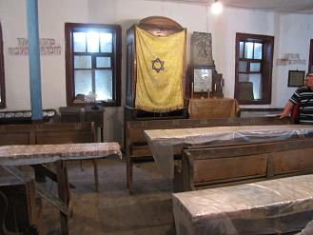

In Bershad exists still an old Synagogue, 200 years

old, and how touching it was to meet the head of the

jewish community there - Yafim Vygodner

(tel. 380435223578\ 0972927499- speaks only Iddish,

and Russian. vugodner@mail.ru ) .Half an hour from Bershad, lies the village of
Obodovka, Surrounded by green fields, furtile, rich land, wheat and vegetables, a cow lying beside the road tied with a chain, or few cows walking around and their owner bikes alonside… The houses are situated along the main road.
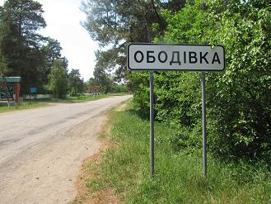

What was once the jewish neighborhood, is located behind the main bus station in the
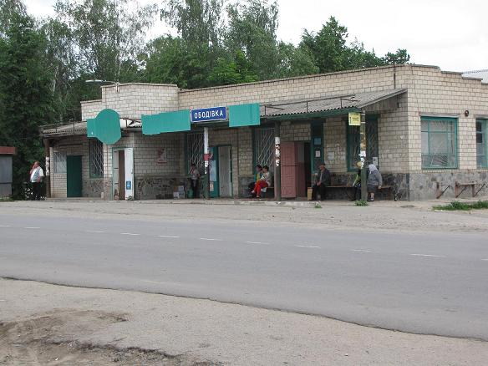
Center. And what is the center of Obodovka? An old bus
Staion: who knows - maybe on one of its columns, my
father was leaning 100 years ago, at the age of 12, when
he said good-by and left for Israel. There are few stores
around and even a simple restaurant with great food - we
ate there and enjoyed every minute. One can cross the street from the restaurant and walk around through the houses, the unpaved roads- old houses beside new ones, water wells in each corner, and friendly people, who welcomed us in their houses. 330 people are living now in Obodovka, among them very few jews.We were wondering around, trying to imagine our dad’s life then- it seems that besides the atmosphere, nothing has changed.
Obodovka cemetery is located on the left side of the entrance to the village- There’s now a big statue of a stork aside the road. Right after that, there’s
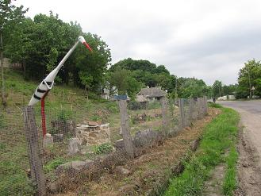
a house and a path. One should enter inside the trees and up
above where’s the old cemetery- a amall one that just half of
the tombs can be recognized.
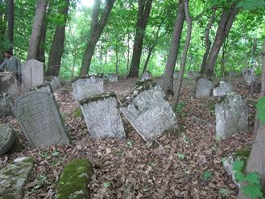

To get to the The Mass Grave of 1919 Pogrom, you have to ask the locals - it’s near a tractor station. In front of it, there’s a monument for the jewish victims of the 1919 Pogrom. If you have relatives that were murdered in
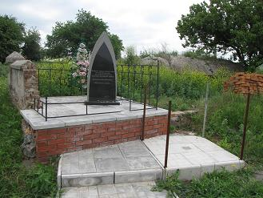
this Pogrom, Maybe you can find their names in the
list of victims written in Rosrntal book “The scroll
of slaughter”. The book was written in Hebrew
"מגילת הטבח")) and existing in the enternet.
Rosental lived then and collected all the evidences and stories that people’ve sent him - he put the towns according to Alef-Bet, and what remained was till the letter ט, so one who reads Hebrew can read about Obodovka אובודובקה)). My grandfather, Issic Berkovitz and his son, Zeev, were murdered then, and I’ve found their names in the nearby village’s list - in Trostinietz. Why there? I knew that they were murdered in 1919th Pogrom and didn’t find their names in the book’s list of Obodovka. Months have passed and before our journey, I’ve decided to check it again- Reading again Obodovka’ evidence, it was written that the Ukraines were moving towards Obodovka from the nearby Trostinietz - I said to my self- who knows, maybe my grandfather and son were there some how- escaping to get help? Working there? Who knows? So I’ve checked Trostinietz’s list and there it was- Issic Berkovitz- a Shohet, and son, Zeev, 22, a Hebrew teacher… What an astounding moment it was! And in Trostinietz there’s a Mass grave also- no names, but a sign. We went there, and in front of the site I’ve told my brothers, who didn’t know, the all story...

It was a toucing, wonderful journey, and the small comfort is that besides the hatred towards the jews during the generations, the wars and Pogroms, our parents or grandfathers had for some time, life in nature, surrounded by its beauty…

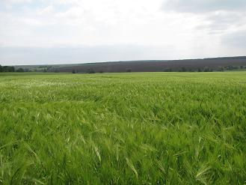

The encyclopedia of jewish life, (editor), Spector Shmuel, vol 2, pp 923

